Activity Sheet Answers
Chapter 5, Lesson 5
Using Dissolving to Identify an Unknown

DEMONSTRATION

- Your teacher did a demonstration comparing the amount of salt and sugar that dissolved in a small amount of water. Was more salt or sugar left in the bottom of the cup? Which dissolved better, salt or sugar?
More salt was left undissolved in the bottom of the cup. The sugar dissolved better than the salt.

- How well a substance dissolves in water is called its solubility. Would you expect different substances to have the same or different solubility? Why?
Different substances should have different solubilities because substances are made up of different ions or atoms on the molecular level—they are chemically different. Water molecules will be attracted to and interact with different substances differently and dissolve them by different amounts.

ACTIVITY
- What do you notice about each crystal? Include any similarities or differences you notice among them.
Answers will vary but most students will mention the shape, size, and transparency of the crystals.

- What do you think might be the identity of the unknown from what you have seen so far?
Answers will vary, but students should conclude that they do not have enough evidence to identify the unknown.
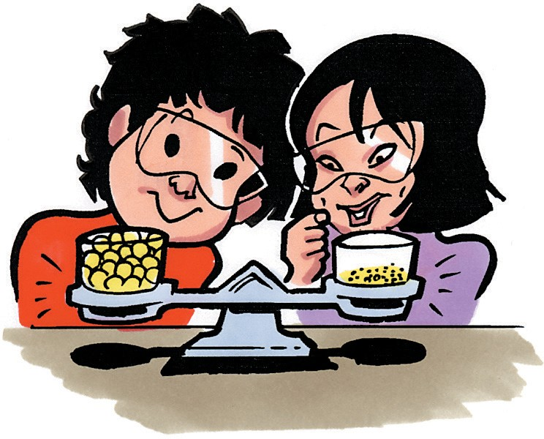
- Your teacher did a demonstration with cereal balls. Look at the cups of cereal on the balance in the picture. Which cup contains more cereal? Why?
They contain the same amount of cereal. The crushed cereal takes up less space, so it has less volume, but the crushed and un-crushed cereal have equal mass, so it is the same amount of cereal.

- In the solubility test you will do, you will need to measure equal amounts of the five crystals. How will you measure equal amounts?
Use a scale to weigh equal amounts of the different crystals. Using a device that relies upon volume would give unequal amounts of different crystals because they take up different amounts of space.

EXPLAIN IT WITH ATOMS & MOLECULES

- On the molecular level, why do different substances have different solubilities?
Substances have different solubilities because they have different chemical compositions. Some substances are made up of ions while others are made up of molecules. The extent to which a substance has areas of positive and negative charge which would associate with water molecules helps determine how soluble that substance will be in water.

- Why does the solubility test help you identify the unknown?
Because different substances have characteristic solubilities, you can use the extent to which they dissolve in water as a clue to identify an unknown. If an unknown has solubility like another known substance, it is likely that they are the same substance.

TAKE IT FURTHER
- What are the similarities and differences between salt dissolving in water and sugar dissolving in water?
Dissolving salt and sugar are similar in that both rely on the small areas of positive and negative charge on a water molecule to be attracted to the particles which make up the whole. The main difference is that when an ionic substance like salt dissolves, individual ions are pulled apart by water, while in a molecular substance like sugar, whole molecules are pulled apart from one another and NOT the individual atoms which make up the molecules.

